14년 3월 1일 10:30 🡪 10/22 10:00

**Part 1**

Q1. Thank you to everyone who attended the computing for success conference. We are deeply grateful to Dr. Lu who organized the conferences and set up lectures. Finally, I want to thank the dedicated, hard working, and efficient staff who made our event reality.  I hope you see you at the next year’s conference.

Q2. Welcome everyone to the Sweets and Treats candy factory. We are excited to show you around our factory which is celebrating its fiftieth anniversary. You will watch a video about our history, production line and some samples of our candy. After that you will be able to purchase your favorites at our gift shop. We have limited time, so let’s get started.

**Part 2(45초)**

This is a picture taken outdoors. On the upper left side of the picture, there are some houses. The houses are alongside of the river. In the middle of the picture, there are many people on the cruise ships. Along the river, there is a street. On the street, there are several people. One of them is riding an orange bicycle. He is carrying a bag pack. Next to him, I can see some trees. On the right side of the picture, there are three men. They are leaning against the fence and wearing casual clothes.

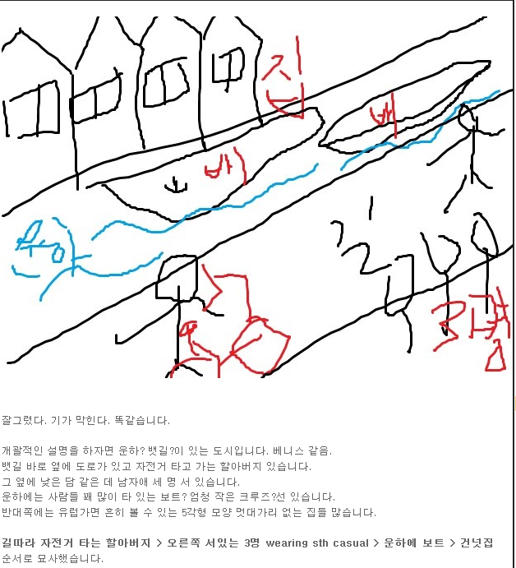

흰머리남자 배낭메고 오렌지색 자전거를 탐, 뒤에 한명 더 자전거를타고있음

배(크루즈선)에 사람들이 많음

자전거 한대 묶여 있음

잎이 풍성한 나무들

3명 난간에 기댐 wearing casual clothes

**Part 3**

Imagine that a technology magazine is doing research in your area. You have agreed to participate in a telephone interview about **video conferences in which people use computers to see and have conversation with co-workers or classmates.**

**Q4.When was the last time you participated in a video conference to communicate with a co-worker or classmate?(15)**

Two weeks ago, I participated in a video conference to communicate with a co-worker. It is very convenient in many ways.

**Q5. In the next few years, do you think you will participate in more video conferences than you do now? Why or why not?(15)**

Yes. I do. The internet has greatly improved. With help of the internet, I will have more chances to participate in video conferences.

**Q6. If you had a meeting, would you prefer to have a video conference or to meet in person? Why?(30)**

I prefer to have video conference. Because I can save time and cost than having a meeting in person. Also, now**a**days, the internet has greatly improved. With help of the internet, I can keep in touch with people far away**.** So, it is more convenient to have a video conference.

**Part 4**

|  |  |
| --- | --- |
| **Professor Tim Kirby**  Agenda for Tuesday April 16th | |
| 8:30-9:00 | Review notes: General medical lecture |
| 9:00-11:00 | Lecture: General medicines |
| 11:30-noon | Interview with Sarah Parks (surgical intern position) |
| Noon-1:00 | Lunch: Dr. Singh |
| 1:00-1:15 | Call David Ross: Confirm details (time, room) for conference presentation |
| 1:30-3:30 | Clients hours |
| 3:30-5:00 | Revise conference presentation notes |

**Narration:** Hi, this is Dr. Kirby. I’d like to prepare for tomorrow, but I don’t have my calendar with me. I need you to tell me a few things about what’s on my schedule.

Q7. What do I have scheduled before 9 o’clock?(15)

**You will give a lecture on general medicines.**

Q8. I’d like to have lunch with Dr. Perris. That won’t be a problem, will it?(15)

**Let me see, No, at that time you will go lunch with Dr. Singh.**

Q9. I know I set a time in the afternoon to prepare conference presentation. Can you tell me all the details about what I am doing tomorrow to prepare for the conference?(30)

**There are three schedules. First, at 1 pm, you will call David Ross. And you should confirm time and room for conference presentation. And then, at 1:30pm there will be clients hours. Finally, at 3:30pm you will revise conference presentation notes.**

**- 7번 8시 반부터 뭐뭐ㅏ시기가 있다.**

**- 8번 안돼 다른 스케줄 있어.**

**- 9번 3개 있었어요. According to the inf I have, there`re 3 sessions. 이후 순서대로 읽음.**

**Part 5**

Q10. Hi, it’s Albert Geiger, the owner of the used book store. Since you are the store manager, I am going to ask you to solve a problem about how to help our customers find books at our store. We have a wide variety books on all kinds of topics and have a clear system for organizing them. It’s just that customers don’t know where to find what they are looking for. Sometimes they think that we don’t have the books they want, and they go somewhere else to buy them. We are starting to lose our business, so I want to make it easier for customers locate specific books in our store. What can we do to help customers find what they are looking for? Please call me back with your ideas. Again, this is Albert. Thanks.

**Hello. Geiger. This is Park. I am the manager.**

**I got your message saying that our customers are complaining that they cannot find books they are looking for. And you are worried that you are losing customers. Right? So, you would like for me to help you out on this matter.**

**I have some ideas for solving these problems.**

**First of all, I think it is a good idea that we should hire more staffs so that they can help people to find books they want. Also, why don’t we set up computers to assist our customers? And put some signs on the shelves. they can easily find what they are looking for.**

**If you have any questions, please call me back. Thank you.**

**Part 6**

Do you agree or disagree with the following statement?

***“The media should not be allowed to report on private lives(라이브스) on public figures(인물들) like politicians and celebrities(유명인사)”.***

Give specific reasons and examples to support your opinion.

I totally agree that the media shouldn’t be allowed to report private lives of public figures like politicians or celebrities.

There are several reasons to support my opinion.

First, it is an abuse of human rights. Even though people have the right to know, people’s privacy should be protected whether they are public figures or not. There is no person who is glad to reveal their life. Put the shoe on the other foot. If I were a person who was reported my private life including where I live, where I go or who I meet, I would feel awful(끔찍).

Second, those articles are nothing more than gossip which is not informative or useful at all. Mass Media should put in more effort to provide more informative information to the public.

I strongly support the idea that mass media shouldn't be permitted to report private lives of public figures for following reasons.

First of all, from the perspective of children, learning private lives of celebrities may have a lot of negative effects.

For example, as you know, a plenty of celebrities are known for committing crimes including drinking and driving **[drunken driving]** and more seriously,**~~a~~ drug taking**.

Once children are exposed to those situations, they might be affected negatively and their behaviors can also be influenced in undesirable way.

In addition, there are also some disadvantages for public figures as well.

To be specific, reporting their private lives may lead to serious invasion of private lives. For example, some media have been accused of reporting celebrities’ love lives which turned out to be rumors. Because of mistaken reports, the celebrities had to go through a hard time.

(In this regard, even though the public has a right to know, it does not mean that they have right to know everything about public figures.)

